ReactJS Hands-on 9 - Cricket App (ES6 Features)

Commands Used
- npx create-react-app cricketapp
- cd cricketapp
- npm start

Project Structure

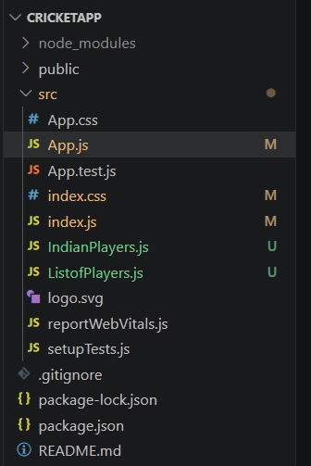

App.js
import React from "react";
import ListofPlayers from "./ListofPlayers";
import {OddPlayers,EvenPlayers,ListofIndianPlayers} from "./IndianPlayers";
function App(){
const flag=true;
const IndianTeam=["Sachin","Dhoni","Virat","Rohit","Yuvraj","Raina"];
if(flag){
return(<div><h1>List of Players</h1><ListofPlayers/></div>);
}
return(<div>
<h1>Odd Players</h1><OddPlayers players={IndianTeam}/>
<hr/><h1>Even Players</h1><EvenPlayers players={IndianTeam}/>
<hr/><h1>List of Indian Players Merged</h1><ListofIndianPlayers/>
</div>);
}
export default App;

ListofPlayers.js
import React from "react";
function ListofPlayers(){
const players=[
{name:"Jack",score:50},{name:"Michael",score:70},{name:"John",score:40},
{name:"Ann",score:61},{name:"Elizabeth",score:61},{name:"Sachin",score:95},
{name:"Dhoni",score:100},{name:"Virat",score:84},{name:"Jadeja",score:64},
{name:"Raina",score:75},{name:"Rohit",score:80}];
const playersBelow70=players.filter(p=>p.score<=70);
return(<div><ul>{players.map((p,i)=><li key={i}>Mr. {p.name} {p.score}</li>)}</ul>
<hr/><h1>List of Players having Scores Less than 70</h1>
<ul>{playersBelow70.map((p,i)=><li key={i}>Mr. {p.name} {p.score}</li>)}</ul></div>);
}
export default ListofPlayers;

IndianPlayers.js
import React from "react";
export function OddPlayers({players}){const[first,,third,,fifth]=players;return(<ul><li>First : {first}</li><li>Third : {third}</li><li>Fifth : {fifth}</li></ul>);}
export function EvenPlayers({players}){const[,second,,fourth,,sixth]=players;return(<ul><li>Second : {second}</li><li>Fourth : {fourth}</li><li>Sixth : {sixth}</li></ul>);}
export function ListofIndianPlayers(){const T20Players=["First Player","Second Player","Third Player"];const RanjiPlayers=["Fourth Player","Fifth Player","Sixth Player"];const IndianPlayers=[...T20Players,...RanjiPlayers];return(<ul>{IndianPlayers.map((p,i)=><li key={i}>Mr. {p}</li>)}</ul>);}

index.js
import React from "react";
import ReactDOM from "react-dom/client";
import "./index.css";
import App from "./App";
const root=ReactDOM.createRoot(document.getElementById("root"));
root.render(<React.StrictMode><App/></React.StrictMode>);

index.css
body{
font-family:Arial;
margin:30px;
}

Output
Flag=true: List of Players and filtered players.
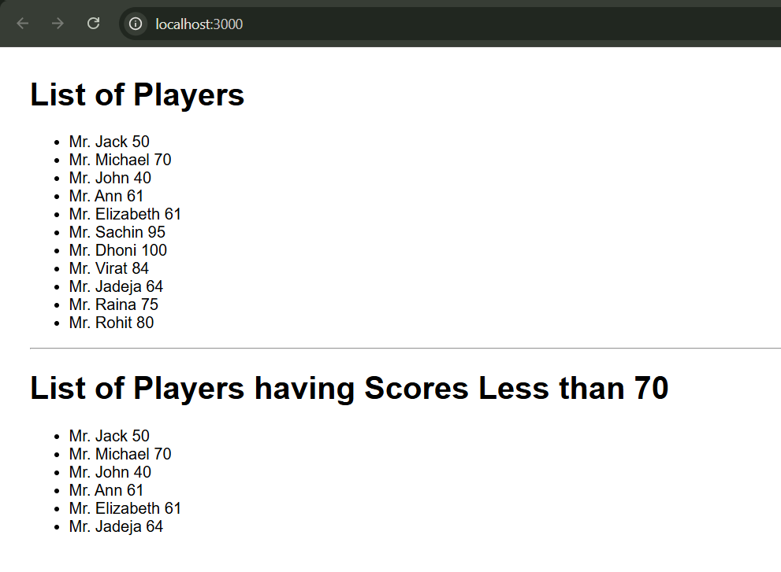
Flag=false: Odd Players, Even Players and merged Indian Players.
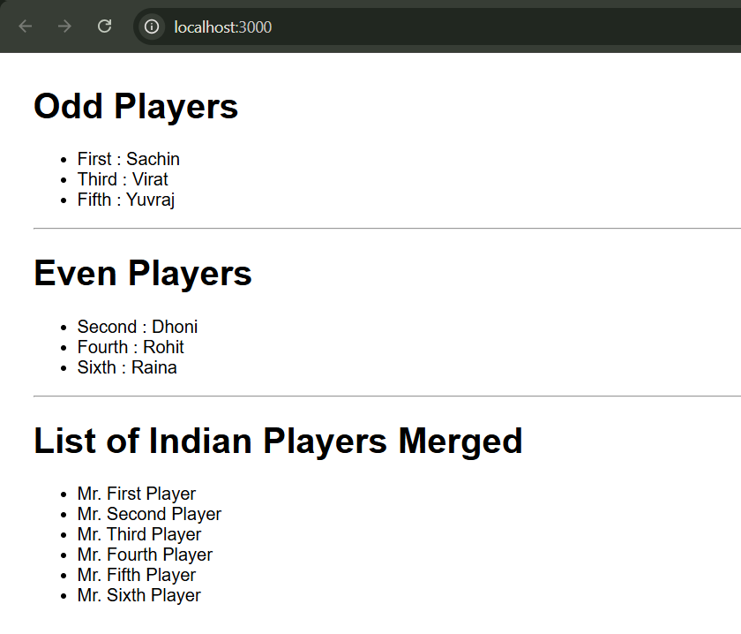

Conclusion
The application successfully demonstrates ES6 map(), filter(), arrow functions, destructuring, spread operator and conditional rendering.

